8 and under
League Rules- Revised 2024

Division Designation

8 years of age- Players cannot turn 9 years old prior to May 1st of the league year. 7 year old players can play up a division with the approval of the League VP.

Each team will consist of 12-14 players. Coaches can select their team and players. Any roster not completed with a minimum of 12 players can have additional players added to their roster by the League VP. The vice president or their designee will be responsible for forming/rostering teams.

Loaning Players:
Players are rostered on a specific team and cannot be loaned to another team or play with another team in League Games. The only exception will be with prior approval of the League VP. The team being loaned players will forfeit and the game can be played as a scrimmage. Coaches caught switching players without approval will be suspended for a minimum of one game.
Time limits/Length of Play

1 hour 15 min. The length of the game may also be determined by run rule or in the event that 6 innings of play have been completed.
While school is in session we will play a drop dead time limit.
No new inning will start with five or less minutes on the clock.
Once school is out we will play to finish the inning. If the home team is ahead and up to bat, the game will be called when the time expires.

Any game canceled/forfeited with less than 24 hours’ notice will result in a $75.00 fine, if this fine is not paid before next scheduled field practice or game, said team will be suspended until fee is paid.

Mercy Rule
20 after 2 innings.
15 after 3 innings,
10-run advantage after 4 innings, (3 ½ if the home team is ahead by 10 runs)
8-run advantage after 5 innings (4 ½ if the home team is ahead by 8 or more runs) shall complete the game.

Umpires:
There will be a zero tolerance for fans or coaches yelling at umpires. The umpire will eject the manager/coaches from the game for misconduct. It is the coaches/managers job to control their fans. Should this become an issue with a team’s fans or coaches the umpire in chief will notify the League VP. Anyone ejected from a game can be subject to a minimum of a one game suspension. (This will be at the discretion of the League VP and UIC.)

Equipment

All Leagues
Each team will be responsible for supplying 2 game balls to the umpire. Game balls will be a quality ball, supplied by the league to each team. Diamond baseballs will be used in all AABC events.

Bats: Bats will be of good quality and should bear a USA bat or USSA official 1.15 stamp. The bat length to weight can be -10, -8, -5, -3 BBCOR or one wood/composite wood stick. Bats can be one or two piece construction.

Note: Teams needing helmets, catchers equipment, practice baseballs ect., will check out equipment with FABC Vice President for their league. Any equipment not returned at the end of the league will be charged to the coach at replacement cost.

Team Dugout Designation
All Divisions
Third base dugout is reserved for the home team and the first base dugout is reserved for the visiting team. Except for tournament play, first come first serve.

Participation Rule/ Line Up/Game Roster/Substitutions

- Teams must have 9 players to start a game. They may finish a game with 8 players due to injury or illness. An out will be recorded in the lineup for the injured/ill player.
- All players shall play at least half of the game. For example, all players shall play at least 2 innings of a four or more inning game and 1 ½ innings for a three inning game to include a minimum of one infield position per game. Coaches may opt to rotate positions more often during a game and should make an effort to rotate players through every position throughout the season. This rule shall apply throughout the season, but shall not apply to city tournament, non-league and/or state tournament games unless deemed by the rules of the governing organization. Note: Failure to comply with the above rules may result in suspension of coaching and forfeiture of games in question.
- All team members shall bat in the order submitted to the official scorekeeper. All team members present for games shall be placed on the batting list and will bat in that order. Players that arrive late will be placed on the end of the batting list. At the coach’s discretion any player may be omitted from the batting list for disciplinary or injury before game time. If a player gets injured or can’t continue to bat in the order turned in. The opposing team will be awarded an out for the missing player when the player comes to bat. Player may come back in his/her order at any time.
- Each team will have their line up into the other team 15 minutes prior to game time.
- If any player present that is not participating in the game, the opposing coach must be notified and noted on the line-up card.
- Free substitution is allowed only at the half inning, unless an injury or illness.

Hitting
- Each team shall list all eligible players on their batting lineup
- Each half inning shall consist of 3 outs or a maximum of 7 runs scored. whichever occurs first.
- An injured player may leave the game and return. If their turn at bat comes up the team will take an automatic out should the player not be available to hit.
- Absolutely no walk up music will be played as the hitter approaches the batter's box.

Score Keeping/Press Box

All coaches should report wins and losses to VP.

Home team shall keep the official book and pitch count. Both team managers/coaches shall sign the official book at the conclusion of the game. The official scorekeeper shall remain neutral and not divulge information unless asked to do so by the umpire or either coach. Home team is allowed one person in the press box to keep score.

ALL TEAMS SHALL HAVE A BOOK (ELECTRONIC OR PAPER) TO BE HEARD IN ANY DISPUTE, AND MUST BE COMPLETE TO THE POINT OF DISPUTE.

Pitch Count Tracking

The official scorekeeper shall be responsible for tracking each of the team’s pitch counts, either through the use of the scorebook or the pitching count chart/counter. Each pitcher’s pitch count is computed by adding the number of balls and strikes, the number of foul balls hit with two strikes, and the number of fair batted balls. Coaches will also keep track of pitch counts, but at no time shall supersede the official scorekeepers count. It is recommended that coaches track pitches and confer with the official scorekeeper after each half inning. A clicker counter is recommended.

Pitch Counts and Pitching Rules
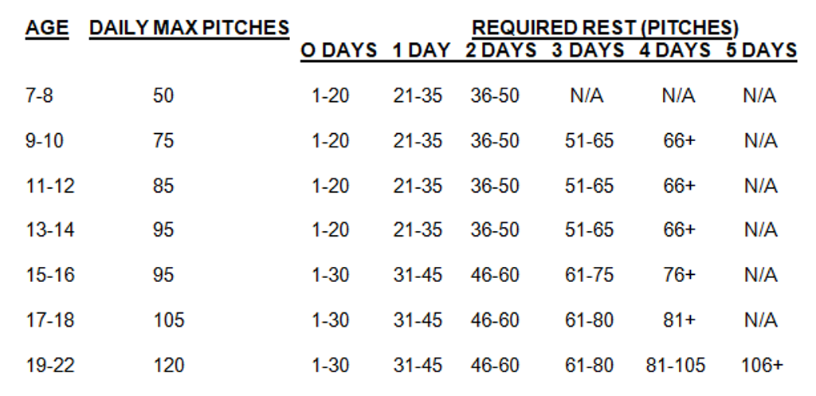

Note: if a coach is found to be guilty of over pitching during the game, the player and coach will be removed from game. The coach will also be suspended for the following game. If a coach does it on a 2nd offense, he will be suspended for 3 games. On the 3rd offense a board meeting will be held during his 5-day suspension to determine if the coach will be allowed to coach in FABC.

The pitching mound (flat or slope) will be 40 feet from home plate with an 18 ft. circle (diameter from the mound) marked on each diamond.

USA PITCH COUNT RULES WILL BE ENFORCED, WITH THE FOLLOWING EXCEPTIONS

A player may pitch in more than one game in a day. If a pitcher throws in a second game on the same day, the total pitches for the day will be calculated and total pitch count shall be calculated per totals listed above. A PITCHER CAN NOT PITCH 3 DAYS IN A ROW, REGARDLESS OF 19 OR LESS RULE
All pitch count rules shall apply regardless of game outcome via rain delay to a new day or suspended games. Unless proper days’ rest has been met.

Once a player is removed from the mound he/she may not return as a pitcher or catcher in the same game. The coach may pitch to the batter in order to allow the ball to be put into play after 4 balls. The coach must pitch from THE BASE OF THE MOUND, a maximum of 3 pitches to a single batter unless there is a fouled third strike, If the player does not hit off the coach it will be scored as an out. EXAMPLE: COUNT IS 4-2, THE BATTER WALKED (TECHNICALLY) THE COACH ONLY GETS 1 PITCH, UNLESS IT’S FOULED OFF. Any pitch from a coach is considered a strike. (during coach pitch all hits will result in a single) The pitcher may then return to the mound to pitch to the next batter. The pitcher must be within the pitchers circle when playing defense in the event that a coach is pitching. Intentional walks are not allowed. The runner cannot advance if the pitcher has the ball in the circle. All kid pitchers will pitch from the mound and pitch to a minimum of 3 complete batters unless the third out occurs in that half of the inning prior to the third batter. In other words, if the pitcher does not face three batters before the half inning ends, the pitcher will not be required to re-enter to throw to additional hitters. Note: The pitcher will be required to throw to 3 complete plate appearances or pitch out of that half of the inning, whichever comes first.

Defensive Play and Dugout Rules

For all teams while playing defense, coaches are allowed and encouraged on the field to give defensive instruction to players but shall in no case interfere with play. Teams may field up to 2 coaches within fair territory. One coach in the infield and one coach in the outfield. This is not applicable during tournament play.
A team may have a manager, 2 assistants and a batboy/girl in the dugout. Maximum of three adults/coaches in the dugout.

Visits to the mound

MLB rule = 5 trips per game and each pitcher must throw to 3 hitters, or the end of an inning. Anything beyond 5 trips will be removal of pitcher from mound, unless injury or change of pitcher.
A coach who visits the same pitcher a second time in the same inning must remove that pitcher. They cannot visit the pitch twice during the same batter.

Overthrows

Play is dead if the ball that is overthrown leaves the playing field, enters a dugout, or another player not currently involved in the play interferes with play. Each runner shall advance one base beyond the base earned prior to stopping the play. It is at the umpires discretion to the base earned prior to the stoppage of the play.

Obstruction Rule/Sliding Rule

In the event a batted ball strikes the coach while pitching or instructing defense in the infield, the batter shall be awarded first base and runners on base will move up one base accordingly. A ball that strikes an outfield defensive positioned coach shall result in two bases. Pitching coaches should use caution to avoid obstructing a player’s ability to make a defensive play.

Players are encouraged to slide if a play is being made or is imminent at the base they are going into. If the player does not slide and contact is made, it is at the discretion of the umpire whether or not the player interfered with the play. If in the umpires judgment interference occurred, the player will be called out. There is no mandatory slide rule. If players do slide, they have to slide legally.

Infield Fly Rule
Infield fly rule will be in effect. Players may advance on a dropped infield fly at their own accord. If the ball is caught, runners must tag up prior to advancing.

Base running

- Lead offs are not permitted. Once the ball crosses home plate, the runner may advance. Note: If an offensive coach is on the field pitching, there will be no base stealing allowed.
If a runner tries to advance before the ball reaches home plate, the following rules apply:
If he arrives safe, he is returned to the original base
If he is tagged before he arrives at the base, the runner is out
If at the same time the batter hits a fair ball, the runner is awarded with a single.
- No runner may advance from third to home unless he is batted home. The runner on third cannot advance on a wild pitch or a passed ball.
- After a missed third strike, the batter cannot advance to first.
Note: Please note that when a player hits the ball, all runners can advance and score. If the hit is in the infield it shall constitute a single, outfield shall constitute a double.
- A foul tip caught by the catcher on the third strike will constitute an out.
- Tagging up after a caught fly ball or a caught foul ball is allowed. After returning to the base he or she started the play from, the runner may advance after the ball is caught at their own risk. They may only advance one base from where they started.
- If returning the runner to the previous base results in two runners occupying that same base the other runner will be returned to his previous base. PLAY IS DEAD.
- Each base runner shall only be allowed 1 base on overthrow with a live ball in play.
Note: If a player is attempting to make a play on a batted ball with a runner running to first base and overthrows the base, the runner is only allowed to proceed to second base. Should an additional overthrow occur that runner is not allowed to advance any additional bases.

Speed of Play (All Leagues)
Coaches should make every effort to speed up play in all leagues whenever possible. This means the teams should be taking the field quickly. Umpires will also carry ball bags to ensure faster speed of play on a passed ball or if a wild pitch is thrown with no runners on first and second.
Note: Courtesy runner for catchers is allowed with 1 or more outs

Warm up Pitches (All Leagues)
Each Pitcher entering the game for the first time will be granted eight initial warm up pitches and five pitches when returning to the mound after the end of half inning of play.

Infield
Pregame infield may be taken as long as both teams have 10 minutes and infield is completed five minutes before game time. Home team takes infield first.

Post Season Play

A division, end of year, city tournament will be played. The seeding for this tournament will be based on head to head competition then record vs like opponents and then to runs. The City Tournament will be played by League Rules.

