16 and Under
League Rules-Revised 2024

Division Designation
15-16 years of age- Players cannot turn 17 years old prior to May 1st of the league year. 14 year old players can play up a division with the approval of the League VP

Each team will consist of 12-14 players. Coaches can select their team and players. Any roster not completed with a minimum of 12 players can have additional players added to their roster by the League VP. The vice president or their designee will be responsible for forming/rostering teams.

Loaning Players:
Players are rostered on a specific team and cannot be loaned to another team or play with another team in League Games. The only exception will be with prior approval of the League VP. The team being loaned players will forfeit and the game can be played as a scrimmage. Coaches caught switching players without approval will be suspended for a minimum of one game.

Time limits/Length of Play
Games shall be 7 innings unless:

2 hour-Time Limits
No new inning will begin after two hours of playing time. No new inning will start with five minutes or less left on the clock. The time will begin after the plate meeting.

*** Extra innings are acceptable to determine a winner within the run rule and time limit formats as noted above.

Any game canceled/forfeited with less than 24 hours’ notice will result in a $125.00 fine, if this fine is not paid before next scheduled field practice or game, said team will be suspended until fee is paid.

Mercy Rule
20 after 2 innings.
15 after 3 innings,
10-run advantage after 4 innings, (3 ½ if the home team is ahead by 10 runs)
8-run advantage after 5 innings (4 ½ if the home team is ahead by 8 or more runs) shall complete the game.

Umpires:
There will be a zero tolerance for fans or coaches yelling at umpires. The umpire will eject the manager/coaches from the game for misconduct. It is the coaches/managers job to control their fans. Should this become an issue with a team’s fans or coaches the umpire in chief will notify the League VP. Anyone ejected from a game can be subject to a minimum of a one game suspension. (This will be at the discretion of the League VP and UIC.)

Equipment

Each team will be responsible for supplying 3 games balls to the umpire. Game balls will be a quality ball, supplied by the league to each team. Teams are responsible for chasing foul balls. Diamond baseballs will be used in all AABC events.

Bats are to be BBCOR (-3), Wood or Wood Composite.

All Helmets and catchers gear will be NOCSAE approved.

Any equipment that is not found to be illegal will be removed. If found in a multiple games with same team the manager will be suspended 5 games

Team Dugout Designation
All Divisions
Third base dugout is reserved for the home team and the first base dugout is reserved for the visiting team. Except for tournament play, first come first serve.

Participation Rule/ Line Up/Game Roster/Substitutions

- Teams must have 9 players to start a game. They may finish a game with 8 players due to injury or illness. An out will be recorded in the lineup for the injured/ill player.
- All team members shall bat in the order submitted to the official scorekeeper. All team members present for games shall be placed on the lineup. At the coach’s discretion any player may be omitted from the batting list or lineup for disciplinary or injury before game time. If a player gets injured or can’t continue to bat in the order turned in. The opposing team will be awarded an out for the missing player when the player comes to bat. Player may come back in his/her order at any time.
- Each team will have their line up into the other team and score keeper 15 minutes prior to game time.
- If any player present that is not participating in the game, the opposing coach must be notified and noted on the line-up card.
- Free substitution is allowed only at the half inning, unless an injury or illness.
- An inning will be constituted by 3 outs.
- Absolutely no walk up music will be played as the hitter approaches the batter's box.

Batting Order
Coaches are free to use the line-up of their choosing:
- straight 9 with substitutes listed
- designated hitter in place of one of the nine defensive players
- line-up of all players present.
The batting order must stay consistent throughout the game. Any player
who leaves and then returns to the batting line-up must occupy the
same place in the order. If a team does not have 9 players in the line-up, an out will be called for the ninth missing batter or for any empty spot if batting all.

Courtesy Runners
Courtesy Runners may be used for the CURRENT listed pitcher or catcher. The “current” pitcher or catcher is the player who last assumed that position in the previous inning. Any player not in the batting order or previously listed in the batting order may be used as the courtesy runner. The spirit of the courtesy runner is to speed up the game, not gain an advantage in speed.
Score Keeping

All coaches should report wins and losses to the VP.

The scorekeeper will be responsible for the official score, scoreboard, and pitch count. No parents or team scorekeepers are allowed in the press box.
Pitch Count Tracking

The official scorekeeper shall be responsible for tracking each of the team’s pitch counts, either through the use of the scorebook or the pitching count chart/counter. Each pitcher’s pitch count is computed by adding the number of balls and strikes, the number of foul balls hit with two strikes, and the number of fair batted balls. Coaches will also keep track of pitch counts, but at no time shall supersede the official scorekeepers count. It is recommended that coaches track pitches and confer with the official scorekeeper after each half inning. A clicker counter is recommended.

ALL TEAMS SHALL HAVE A BOOK (ELECTRONIC OR PAPER) TO BE HEARD IN ANY DISPUTE, AND MUST BE COMPLETE TO THE POINT OF DISPUTE.

Pitch Counts and Pitching Rules
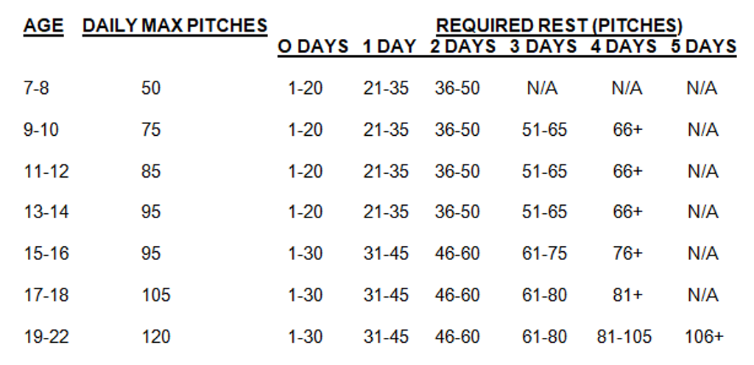

Note: If a coach is found to be guilty of over pitching during the game, The coach will be suspended for the following game. If a coach does it on a 2nd offense, he will be suspended for 3 games. On the 3rd offense a board meeting will be held during the coaches 5-day suspension on if they will be allowed to coach in FABC.

A player may pitch in more than one game in a day. If a pitcher throws in a second game on the same day, the total pitches for the day will be calculated and total pitch count shall be calculated per totals listed above. A PITCHER CAN NOT PITCH 3 DAYS IN A ROW, REGARDLESS OF 19 OR LESS RULE
All pitch count rules shall apply regardless of game outcome via rain delay to a new day or suspended games..

Defensive Play and Dugout Rules

Coaches may be on the first base coach’s box and third base coach’s box while their team is batting. One coach may be outside of the dugout on a bucket while their team is on defense. All other coaches must remain in the dugout.
Teams may have one manager and three coaches in the dugout at any given time.

Visits to the mound

MLB rule = 5 trips per game and each pitcher must throw to 3 hitters, or the end of an inning. Anything beyond 5 trips will be removal of the pitcher from the mound, unless injury or change of pitcher.
A coach who visits the same pitcher a second time in the same inning must remove that pitcher. They cannot visit the pitcher twice during the same batter.

Obstruction/Interference Rule/Sliding Rule

Offensive interference- Players are encouraged to slide if a play is being made or is imminent at the base they are going into. If the player does not slide, it is at the discretion of the umpire whether or not the player interfered with the play. If in the umpire's judgment interference occurred, the player will be called out. There is no mandatory slide rule. If players do slide, they have to slide legally.

Defensive Obstruction- Players not in possession of the baseball can not hinder or obstruct a runner’s ability from obtaining the base. This is at the judgment and discretion of the umpire.

Infield Fly Rule

The infield fly rule will be in effect

Speed of Play
Coaches should make every effort to speed up play in all leagues whenever possible. This means the teams should be taking the field quickly. Umpires will also carry ball bags to ensure faster speed of play.

Warm up Pitches
Each Pitcher entering the game for the first time will be granted eight initial warm up pitches and five pitches when returning to the mound after the end of the half inning of play.

Infield
Pregame infield may be taken as long as both teams have 10 minutes and infield is completed five minutes before game time. Home team takes infield first.

Post Season Play

A division, end of year, city tournament will be played. The seeding for this tournament will be based on head to head competition then record vs like opponents and then to runs. The City Tournament will be played by League Rules.

